FRIENDS AND FAMILY TEST
Results for October 2023

Thank you to all the patients who completed a friends and family test survey in October 2023.

1. How likely are you to recommend our practice to family and friends if they needed similar care or treatment?
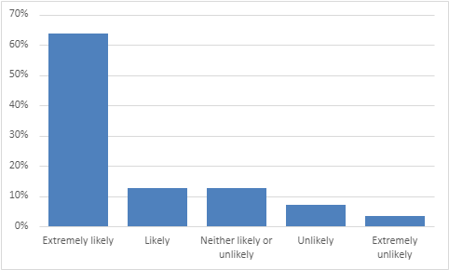
64% are extremely likely to recommend the practice.
13% are likely to recommend the practice.
13% are neither likely nor unlikely to recommend the practice.
7% are unlikely to recommend the practice.
4% are extremely unlikely to recommend the practice.

2. If we could change one thing about your care or treatment what would it be?
- I feel extremely lucky to have such a wonderful GP surgery.
- I was completely satisfied with my recent treatment and could not find any faults at all.
- Just perfect and treated with care.
- Dr Hart has taken the time to listen and understand.
- Dr Harris has been excellent with me.
- Five stars to Dr Brown.
- Staff are excellent, efficient and friendly.
- I wouldn’t recommend any changes; I am completely satisfied with the care I have received.
- Love the call back system.
- Well women clinic.
- Appointment system that works for the patient, not just the practice.
- To be able to get an appointment easier and quicker. More face-to-face appointments.
- Releasing appointments daily is ridiculous for people who need to plan ahead.
- Quicker result notifications.

